Day 01

Vehicle id: 0

SMAK (0) --> EX ASCON RESIDENCE (1728) --> FC DEMATAGODA 02 (1497) --> EX OVAL VIEW RESIDENCE (1872) --> FC COTA ROAD (1471) --> EX ROYALPARK (1320) --> Kotta Road (SCCR) --> Rajagiriya (SCSJ) --> Rajagiriya 2 (SCRJ) --> Nawala (SCNW) --> NAWALA (14008) --> EX NARAHENPITA (1761) --> EX TRILLIUM RESIDENCE (1323) --> EX WIJERAMA MAWATHA (1859) --> FC WARD PLACE (1446) --> FC GRANDPASS (1292) --> SMAK (0) --> Route Distance: 36km (Max: 100km) Visits: 15 (Max: 15)

Vehicle id: 1

SMAK (0) --> Kiribathgoda SS (14) --> Kiribathgoda (SGKB) --> Sinharamulla (SGSM) --> Kelaniya (SGKY) --> Kiribathgoda 2 (SGKG) --> Eldeniya (SGEL) --> Kirillawala (SGK5) --> Weliweriya Daily (156) --> Miriswatta (SGMP) --> Yakkala SS (114) --> Thihariya (SGTI) --> Yakkala (SGYK) --> Gampaha SC (24) --> Gampaha 2 (SGGP) --> Ganemulla (SGGE) --> SMAK (0) --> Route Distance: 64km (Max: 100km) Visits: 15 (Max: 15)

Vehicle id: 2

SMAK (0) --> FC MUTUWAL (1137) --> Mattakuliya (SCMY) --> Kotahena 2 (SCK7) --> FC KOTAHENA (1108) --> Kotahena (SCKE) --> EX PORT AUTHORITY (1818) --> FC SLAVE ISLAND (1672) --> Hyde Park SC (5) --> FC STAPLES STREET (1017) --> Union Place (SCUP) --> EX ALEXANDRA PLACE (1303) --> ASIRI CENTRAL (14003) --> FC MARADANA (1145) --> FC NORRIS CANAL (1433) --> EX DEANS ROAD (1364) --> SMAK (0) --> Route Distance: 34km (Max: 100km) Visits: 15 (Max: 15)

Vehicle id: 3

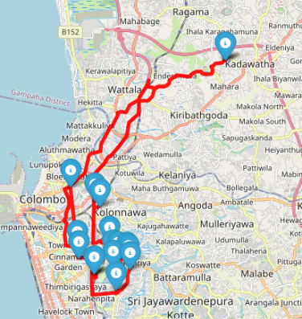SMAK (0) --> Enderamulla (SGEM) --> FC GLORIOUS RESIDENCE (1545) --> Shangri-La Mall (SCSL) --> EX MARADANA 02 (1759) --> Thurstan (SCTU) --> Duplication Road (SCDP) --> Marine Drive (SCMD) --> EX BAMBALAPITIYA (1308) --> FC MOUNT LAVINIA STC (1130) --> FC MAJESTIC CITY (1033) --> FC DUPLICATION (1411) --> Crescat (SCCC) --> FC FORT (1005) --> Darley Road (SCDR) --> FC BLOEMENDHAL (1555) --> SMAK (0) --> Route Distance: 41km (Max: 100km) Visits: 15 (Max: 15)

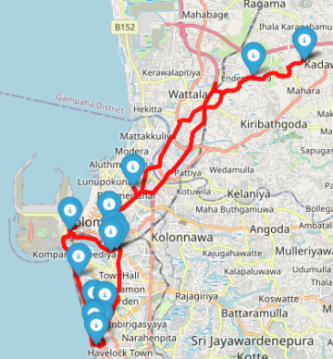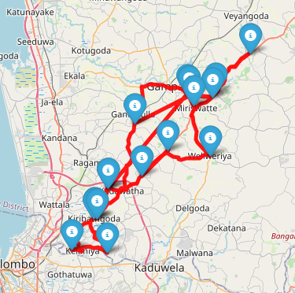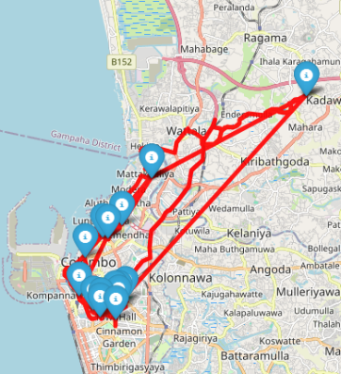

Vehicle id: 4

SMAK (0) --> CR FC (14011) --> FC JAWATTA (1419) --> EX THIMBIRIGASYAYA (1107) --> EX ISIPATHANA MAWATHA (1888) --> Thimbirigasyaya (SCTB) --> FC BAUDDHALOKA MAWATHA (1676) --> FC GREEN PATH (1661) --> FC COLPETTY (1105) --> FC KOLLUPITIYA 02 (1608) --> EX YMCA (1826) --> FC COLOMBO CITY CENTER (1902) --> EX MALIGAWATTE2 (1746) --> EX MALIGAWATTE (1301) --> EX MALIGAWATTE 03 (1776) --> EX ORION CITY (1896) --> SMAK (0) --> Route Distance: 36km (Max: 100km) Visits: 15 (Max: 15)

Vehicle id: 5

SMAK (0) --> Kandana Daily (171) --> JA Ela 3 (SGJW) --> Diuwalapitiya (SGDL) --> Minuwangoda (SGMI) --> Minuwangoda SC (123) --> Negombo 2 (SGN2) --> NEGOMBO (14007) --> Negombo SC (26) --> Negombo Kurana (SGNK) --> Seeduwa SC (128) --> Seeduwa (SGSE) --> Kochchikade (SGKC) --> FC WATTALA (1084) --> Ja Ella (SGJA) --> KANDANA (14013) --> SMAK (0) --> Route Distance: 66km (Max: 100km) Visits: 15 (Max: 15)

Vehicle id: 6

SMAK (0) --> Mawaramandiya (SGMQ) --> EX ERIYAGAMA (1355) --> FC BIYAGAMA (1548) --> FC BOMIRIYA (1549) --> Akuregoda (SCAK) --> Vidyala Junction (SCVJ) --> Arangala (SCAR) --> Pittugala (SCPT) --> Thalahena (SCTH) --> Biyagama (SCBI) --> Mawanella (SLMN) --> Malabe SS (110) --> MALABE (14010) --> FC KOTHALAWALA (1678) --> Kaduwela (SCKX) --> SMAK (0) --> Route Distance: 50km (Max: 100km) Visits: 15 (Max: 15)

Vehicle id: 7

SMAK (0) --> EX RAHULA JUNCTION (1745) --> Gothatuwa (SCGT) --> FC KOLONNAWA 02 (1614) --> Wellampitiya (SCWP) --> Mulleriyawa -Angoda (SCMU) --> Mulleriyawa Daily (172) --> Tyre Junction (SGTY) --> WATTALA (14015) --> Kerawalapitiya (SGKR) --> Wattala 2 (SGWA) --> Wattala-2 ADA (117) --> Wattala SC (3) --> Welisara (SGMH) --> Ragama (SGRA) --> Ragama Daily (150) --> SMAK (0) --> Route Distance: 36km (Max: 100km) Visits: 15 (Max: 15)

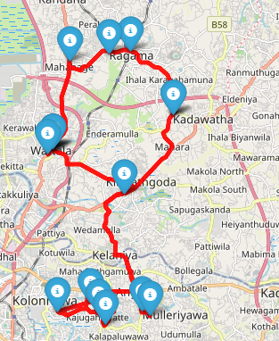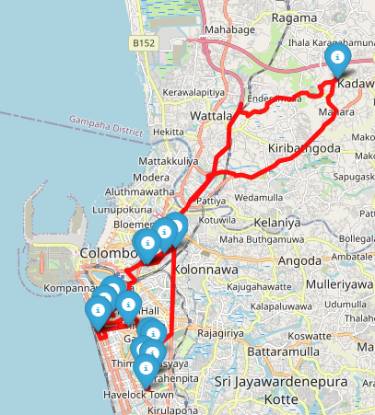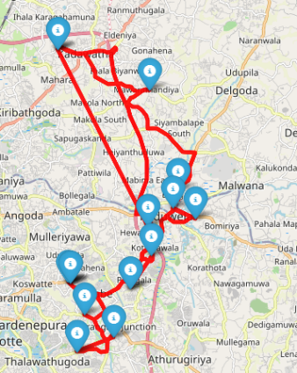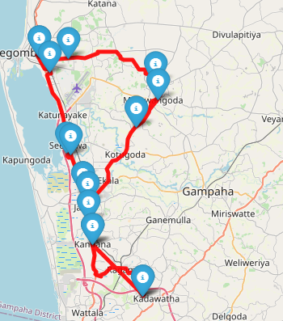Total distance for all vehicles: 363km

Day 02

Vehicle id: 0

SMAK (0) --> EX THALDUUWA (1760) --> FC PALMADULLA (1412) --> Ehaliyagoda (SREG) --> FC EHELIYAGODA (1186) --> EX KURUWITA (1321) --> FC RATNAPURA (1104) --> Rathnapura Main Arpico Daily (188) --> FC BANDARAGAMA (1279) --> Rathnapura (SRRP) --> FC RATNAPURA 03 (1546) --> Rathnapura 2 (SRRR) --> FC RATHNAPURA 02 (1576) --> FC AVISSAWELLA (1116) --> FC AVISSAWELLA 02 (1667) --> Avissawella (SCAV) --> SMAK (0) --> Route Distance: 172km (Max: 200km) Visits: 15 (Max: 15)

Vehicle id: 1

SMAK (0) --> FC KEGALLE 02 (1567) --> Kegalle SC (115) --> Kegall (SLKV) --> FC PILIMATALAWA (1157) --> FC NAWALAPITIYA (1289) --> FC GATAMBE (1467) --> ASIRI KANDY (14004) --> EX GELIOYA (1360) --> Kandy (SKKA) --> FC KANDY (1018) --> Kandy SC (27) --> KANDY - MCC (14014) --> Kandy 3 (SKKI) --> Kandy 2 (SKK2) --> FC NUWARA ELIYA (1020) --> SMAK (0) --> Route Distance: 193km (Max: 200km) Visits: 15 (Max: 15)

Vehicle id: 2

SMAK (0) --> EX ALAWWA (1324) --> FC NARAMMALA (1490) --> EX MALKADUWAWA (1735) --> FC KURUNEGALA (1076) --> EX YANTHAMPALAWA (1844) --> Kurunegala 03 (SNRN) --> FC KURUNEGALA 04 (1680) --> Kurunegala SC (111) --> FC KURUNEGALA 03 (1498) --> Kurunegala 02 (SNRU) --> KURUNEGALA (14005) --> EX POTHUHERA (1887) --> FC PUTTALUM (1443) --> EX ALAWWA 02 (1810) --> FC WARAKAPOLA (1133) --> SMAK (0) --> Route Distance: 162km (Max: 200km) Visits: 15 (Max: 15)

Vehicle id: 3

SMAK (0) --> Homagama (SCHG) --> KOTTAWA (14006) --> Pannipitiya (SCPN) --> Kottawa 3 (SCK3) --> Kottawa SS (108) --> Kesbewa (SCKZ) --> Kesbewa 2 (SCKJ) --> Piliyandala (SCPI) --> Piliyandala SS (76) --> EX MABULGODA (1892) --> Homagama SC (113) --> Godagama (SCGO) --> EX NAWAGAMUWA (1762) --> Athurugiriya Daily (152) --> Athurugiriya 2 (SCA2) --> SMAK (0) --> Route Distance: 69km (Max: 150km) Visits: 15 (Max: 15)

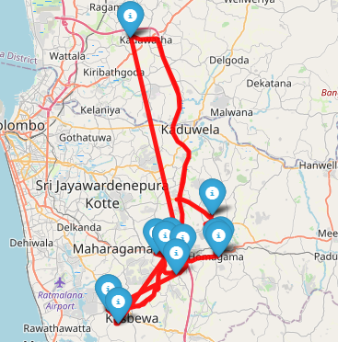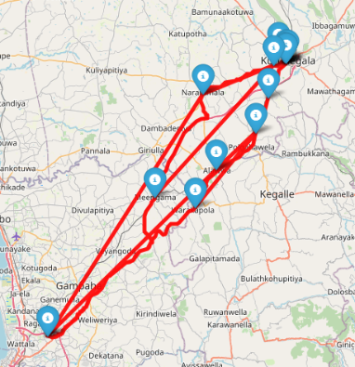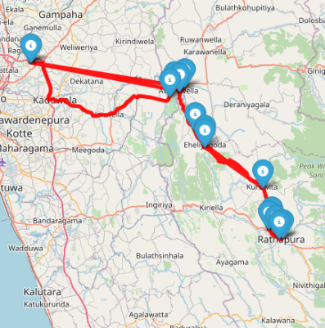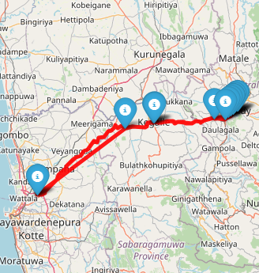

Vehicle id: 4

SMAK (0) --> Nugegoda 2 (SCNG) --> Maharagama (SCMG) --> Maharagama 3 (SCMF) --> EX MAKULUDUWA (1739) --> Piliyandala 2 (SCPA) --> EX SUWARAPOLA (1327) --> katubedda (SCK6) --> Moratuwa 3 (SCMW) --> Gorakana (SIGN) --> Panadura SC (106) --> Panadura 03 (SIP4) --> Horana (SIHZ) --> EX RAIGAMA (1836) --> EX WATAREKA (1840) --> Watareka Daily (181) --> SMAK (0) --> Route Distance: 116km (Max: 150km) Visits: 15 (Max: 15)

Vehicle id: 5

SMAK (0) --> FC PARK ROAD (1109) --> EX HAVELOCK ROAD (1305) --> Havelock Road (SCHR) --> FC DICKMANS ROAD (1291) --> FC JAYA ROAD (1594) --> Wellawatte SS (25) --> Mount Lavinia (SCML) --> Moratuwa Mall (SCM2) --> Rathmalana (SCRM) --> Aththiditya Daily (168) --> MOUNT - LAVINIA (14009) --> Attidiya 02 (SCAD) --> Delpe (SGRD) --> Kalubowila (SCKL) --> Edmonton (SCET) --> SMAK (0) --> Route Distance: 58km (Max: 120km) Visits: 15 (Max: 15)

Vehicle id: 6

SMAK (0) --> Battaramulla SC (22) --> Kotte (SCKO) --> Kohuwala (SCKH) --> Pitakotte 2 (SCPO) --> Nawinna SC (10) --> Gamsabha (SCGS) --> DELKANDA (14001) --> Kohuwala 2 (SCPY) --> Kohuwala SC (112) --> Dehiwala (SCDE) --> EX DEHIWALA (1774) --> FC DEHIWALA (1106) --> FC MARINE CITY (1484) --> Dehiwala SC (23) --> FC W. A. SILVA MAWATHA (1650) --> SMAK (0) --> Route Distance: 51km (Max: 120km) Visits: 15 (Max: 15)

Vehicle id: 7

SMAK (0) --> EX MALWANA (1338) --> Thalawathugoda 3 (SCTL) --> Pitakotte (SCPK) --> Thalawathugoda 2 (SCTG) --> THALAWATHUGODA (14012) --> Thalawathugoda SC (116) --> Battaramulla (SCBT) --> Thalawathugoda (SCCM) --> Embuldeniya (SCED) --> Wijerama (SCWJ) --> Boralasgomuwa (SCBL) --> Raththanapitiya (SCRT) --> Borelasgamuwa SS (4) --> Maharagama 2 (SCM3) --> Hokandara (SCHD) --> SMAK (0) --> Route Distance: 66km (Max: 120km) Visits: 15 (Max: 15)

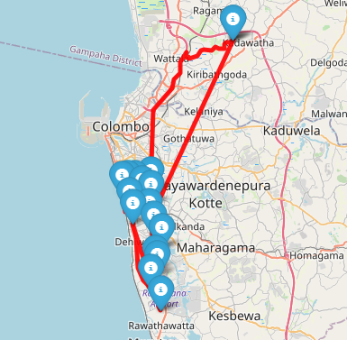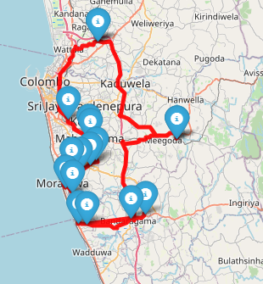Total distance for all vehicles: 887km

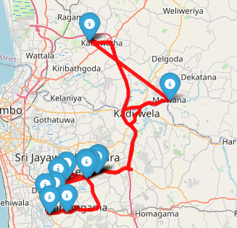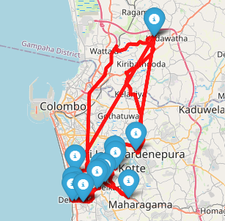

Day 03

Vehicle id: 0

SMAK (0) --> EX IBBAGAMUWA (1377) --> EX IBBAGAMUWA 02 (1791) --> EX MELSIRIPURA (1341) --> FC GALEWELA (1430) --> FC DAMBULLA 02 (1571) --> FC DAMBULLA (1158) --> EX PALAPATHWELA (1770) --> EX MATALE ROSE ST (1350) --> FC MATALE (1124) --> FC MATALE 03 (1659) --> Matale (SYMT) --> FC PILIMATHALAWA 02 (1592) --> SMAK (0) --> Route Distance: 307km (Max: 400km) Visits: 12 (Max: 12)

Vehicle id: 1

SMAK (0) --> FC MAWANELLA (1199) --> Haloluwa Daily (80) --> FC KATUGASTOTA2 (1460) --> Katugasthota (SKKM) --> Kundasale SS (121) --> FC PALLEKELE (1464) --> EX DIGANA (1319) --> FC KUNDASALE (1170) --> EX AMPITIYA (1357) --> EX GALAHA ROAD (1600) --> FC KIRIBATHKUMBURA (1663) --> FC KEGALLE (1111) --> SMAK (0) --> Route Distance: 241km (Max: 400km) Visits: 12 (Max: 12)

Vehicle id: 2

SMAK (0) --> EX BADDEGAMA (1787) --> FC KARAPITIYA (1187) --> Karapitiya (SFK4) --> FC THANIPOLGAHA JUNCTION (1664) --> Galle SC (109) --> Galle (SFGL) --> EX NELUWA (1724) --> FC GALLE (1121) --> EX HIKKADUWA (1370) --> FC AMBALANGODA (1117) --> FC AMBALANGODA2 (1466) --> Ambalangoda Daily (163) --> SMAK (0) --> Route Distance: 254km (Max: 300km) Visits: 12 (Max: 12)

Vehicle id: 3

SMAK (0) --> EX PIDURUWELLA (1845) --> FC MAWATHAGAMA (1671) --> EX GALAGEDARA (1394) --> EX POOJAPITIYA (1717) --> EX WATTEGAMA (1371) --> FC AKURANA (1159) --> Ambatenna Daily (175) --> Katugastota SC (122) --> FC KATUGASTOTA (1113) --> EX ALADENIYA (1749) --> EX RAMBUKKANA (1386) --> FC RAMBUKKANA (1597) --> SMAK (0) --> Route Distance: 242km (Max: 300km) Visits: 12 (Max: 12)

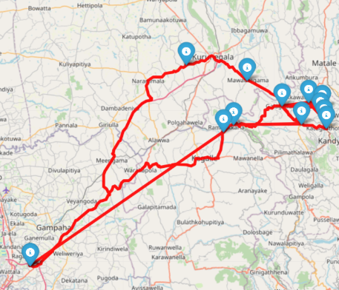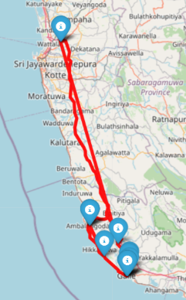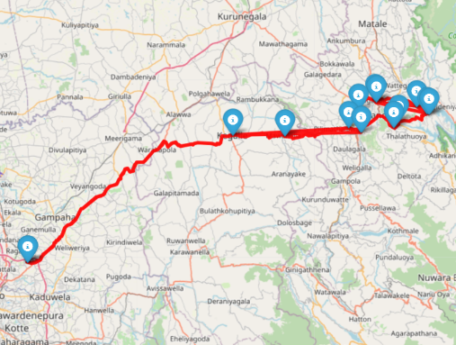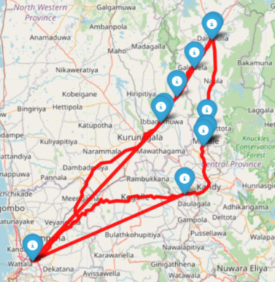

Vehicle id: 4

SMAK (0) --> EX KARANDENIYA (1349) --> Ambalangoda Daily (163) --> FC AMBALANGODA (1117) --> FC AMBALANGODA2 (1466) --> Ambalangoda (SFAB) --> EX AHUNGALLA (1781) --> EX URAGASMANHANDIYA (1763) --> Panadura 2 (SIP2) --> Nalluruwa (SINL) --> Wadduwa (SIWD) --> EX BENTOTA (1331) --> Kaluthara 2 (SIWK) --> SMAK (0) --> Route Distance: 213km (Max: 250km) Visits: 12 (Max: 12)

Vehicle id: 5

SMAK (0) --> Kalutara SS (79) --> Kaluthara (SIKS) --> Katukurunda SC (127) --> EX MAGGONA (1727) --> FC BERUWELA (1115) --> Beruwala (SIBE) --> Aluthgama (SIAL) --> FC ALUTHGAMA 02 (1589) --> FC ALUTHGAMA (1114) --> FC DHARGA TOWN (1286) --> EX SOUTHERN HIGHWAY A (1352) --> EX SOUTHERN HIGHWAY B (1353) --> SMAK (0) --> Route Distance: 153km (Max: 200km) Visits: 12 (Max: 12)

Vehicle id: 6

SMAK (0) --> EX RUWANWELLA (1322) --> EX KANNATHTHOTA (1854) --> EX KOTIYAKUBURA (1326) --> EX BULATHKOHUPITIYA (1802) --> EX YATIYANTOTA (1825) --> EX DERANIYAGALA (1372) --> SMAK (0) --> Route Distance: 169km (Max: 200km) Visits: 6 (Max: 12)

Vehicle id: 7

SMAK (0) --> Negombo Telwatta (SGNO) --> Dalupotha (SGND) --> Kochchikade SC (119) --> Wennappuwa (SPWN) --> Wennapuwa Daily (167) --> Maravila (SPMV) --> Chilaw (SPCH) --> Chilaw Daily (174) --> Kuliyapitiya Daily (161) --> FC KULIYAPITIYA 02 (1619) --> FC KULIYAPITIYA (1278) --> FC PANNALA (1281) --> SMAK (0) --> Route Distance: 180km (Max: 200km) Visits: 12 (Max: 12)

Total distance for all vehicles: 1821km

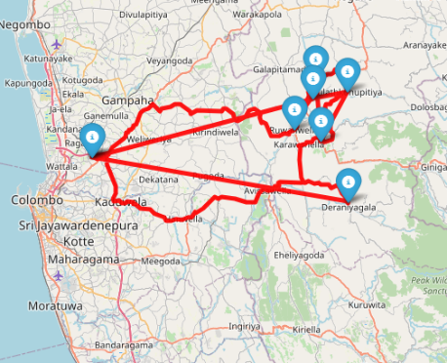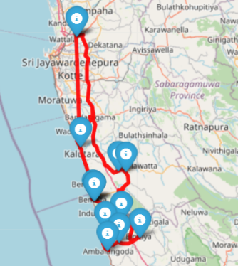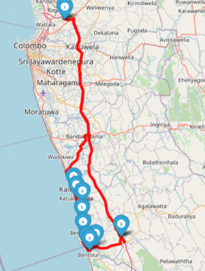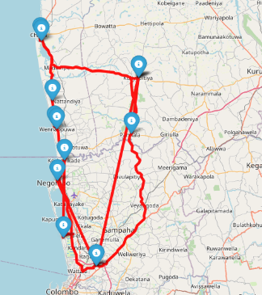

Day 04

Vehicle id: 0

SMAK (0) --> Pelmadulla Arpico Daily (191) --> EX UDAWALAWA (1779) --> FC EMBILIPITIYA (1138) --> Embilipitiya (SREP) --> EX MIDDENIYA (1339) --> EX WEERAKETIYA (1853) --> EX TANGALLE (1803) --> Tangalle (SHTA) --> FC TANGALLE 02 (1697) --> FC TANGALLE (1169) --> EX BELIATTA (1343) --> EX THIHAGODA (1806) --> SMAK (0) --> Route Distance: 402km (Max: 500km) Visits: 12 (Max: 12)

Vehicle id: 1

SMAK (0) --> EX POTHUPITIYA (1796) --> EX GODAKAWELA (1368) --> EX PALLEBEDDA (1801) --> FC BALANGODA (1139) --> FC HATTON (1164) --> FC GAMPOLA (1188) --> EX GINIGATHHENA (1379) --> Gampola (SKGZ) --> FC GAMPOLA 02 (1607) --> FC MATALE2 (1481) --> Matale 2 (SYMX) --> EX MADAWALA ULPOTHA (1816) --> SMAK (0) --> Route Distance: 488km (Max: 500km) Visits: 12 (Max: 12)

Vehicle id: 2

SMAK (0) --> FC KARAPITIYA 02 (1651) --> EX LABUDUWA (1772) --> EX PINNADUWA FAIRWAY (1766) --> EX HABARADUWA (1366) --> EX UNAWATUNA (1773) --> EX KATUGODA (1387) --> EX GALLE FORT (1785) --> FC GALLE 02 (1444) --> Galle 2 (SFGA) --> EX HAPUGALA (1800) --> EX HIKKADUWA 02 (1847) --> EX ARACHCHIKANDA (1809) --> SMAK (0) --> Route Distance: 287km (Max: 400km) Visits: 12 (Max: 12)

Vehicle id: 3

SMAK (0) --> Matara (SMMR) --> Matara 3 (SMMC) --> FC MATARA (1083) --> Matara 2 (SMMS) --> FC MATARA 02 (1550) --> Matara SC (105) --> EX MATARA (1201) --> FC WALGAMA (1655) --> FC MIRISSA (1579) --> FC WELIGAMA (1469) --> EX AHANGAMA (1718) --> EX PINNADUWA 02 (1862) --> SMAK (0) --> Route Distance: 320km (Max: 400km) Visits: 12 (Max: 12)

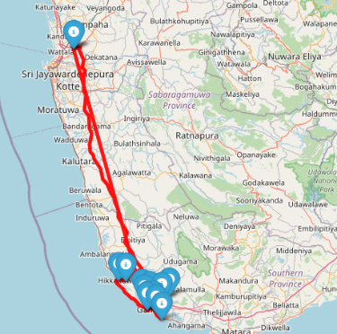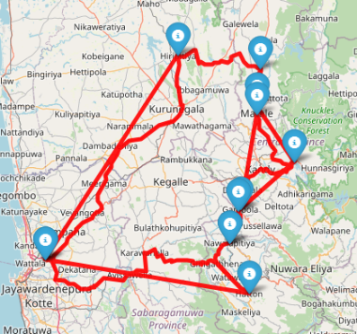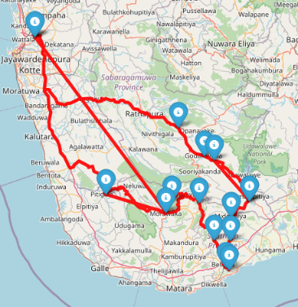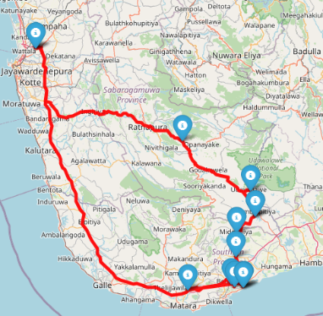

Vehicle id: 4

SMAK (0) --> EX DODANGODA (1784) --> EX PITIGALA (1797) --> FC AKURESSA (1459) --> EX MORAWAKA (1780) --> EX DENIYAYA (1385) --> EX URUBOKKA (1841) --> EX WALASMULLA (1807) --> EX KEKANADURA (1842) --> FC DICKWELLA (1153) --> EX RANNA (1852) --> FC AMBALANTHOTA (1155) --> FC HAMBANTOTA (1150) --> EX DEBARAWEWA (1869) --> FC THISSAMAHARAMA (1457) --> EX KATARAGAMA (1736) --> EX BUTTALA (1375) --> FC WELLAWAYA (1470) --> EX HALDUMMULLA (1790) --> FC BANDARAWELA (1015) --> EX BINDUNUWEWA (1756) --> FC BADULLA (1125) --> FC BADULLA 02 (1669) --> EX BADULLA (1788) --> FC WELIMADA (1435) --> EX RIKILLAGASKADA (1777) --> SMAK (0) --> Route Distance: 833km (Max: 900km) Visits: 25 (Max: 25)

Vehicle id: 5

SMAK (0) --> EX HIRIPITIYA (1828) --> EX HABARANA (1381) --> EX KANTHALE (1782) --> FC TRINCOMALEE (1162) --> EX TRINCOMALEE (1316) --> EX MUTUR (1866) --> EX VALACHCHENEI (1891) --> FC ERAVUR (1448) --> FC BATTICALOA 02 (1429) --> FC BATTICALOA (1288) --> EX ARAYAMPATHY (1864) --> EX KALUWANCHIKUDI (1885) --> FC KALMUNEI (1424) --> EX KALMUNAI (1738) --> EX NINTAVUR (1850) --> FC SAMANTHURAI (1453) --> FC AMPARA (1294) --> FC AKKARAIPATHTHU (1425) --> FC POTHUVIL (1439) --> FC MONERAGALA (1297) --> FC BIBILA (1695) --> FC MAHIYANGANAYA (1584) --> EX THELDENIYA (1843) --> SMAK (0) --> Route Distance: 886km (Max: 900km) Visits: 23 (Max: 25)

Vehicle id: 6

SMAK (0) --> EX NOROCHCHOLAI (1795) --> EX MANNAR (1741) --> FC JAFFNA (1148) --> FC KANNATHTHIDI (1432) --> FC MANIPPAY (1422) --> FC CHUNNAKAM (1455) --> EX KOPAY (1867) --> EX NELLIYADI (1342) --> FC KILINOCHCHI (1431) --> EX VAVUNIYA (1834) --> FC VAVUNIYA (1146) --> EX MADAWACHCHIYA (1383) --> FC ANURADHAPURA (1120) --> Anuradhapura (SAAP) --> Anuradhapura Arpico Daily (190) --> FC ANURADHAPURA 02 (1559) --> EX THAMBUTHTHEGAMA (1858) --> EX GALGAMUWA (1335) --> EX AMBANPOLA (1799) --> FC WARIYAPOLA (1428) --> SMAK (0) --> Route Distance: 860km (Max: 900km) Visits: 20 (Max: 20)

Vehicle id: 7

SMAK (0) --> EX MULLAITTIVE (1393) --> FC POLONNARUWA (1616) --> FC KADURUWELLA (1434) --> EX JAYANTHIPURA (1783) --> EX KEKIRAWA (1743) --> FC IPALOGAMA (1298) --> Puttalam (SPPU) --> EX ANAMADUWA (1726) --> SMAK (0) --> Route Distance: 508km (Max: 900km) Visits: 8 (Max: 20)

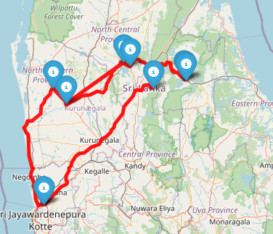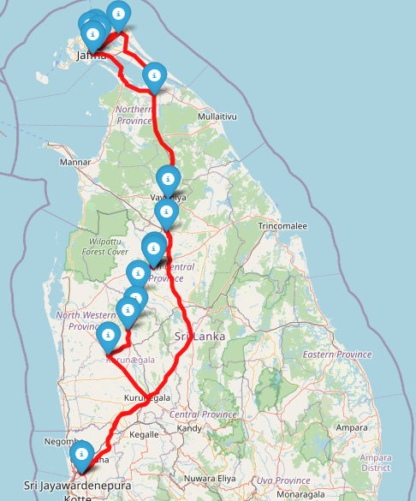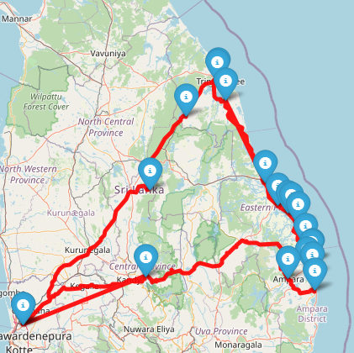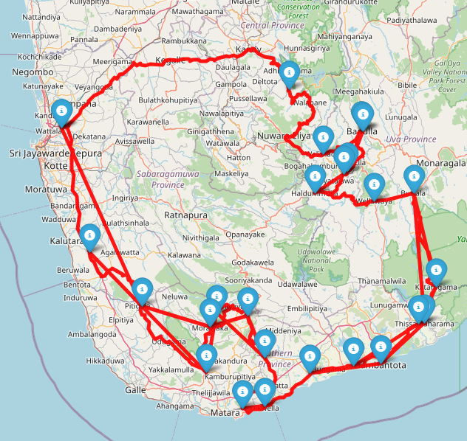Total distance for all vehicles: 4584km

Day 05

Vehicle id: 0

SMAK (0) --> FC VEYANGODA (1690) --> EX KANDALAMA (MIRIGAMA) (1873) --> SMAK (0) --> Route Distance: 81km (Max: 150km) Visits: 2 (Max: 12)

Vehicle id: 1

SMAK (0) --> FC WALPOLA (1673) --> EX CAPITAL HEIGHTS (1886) --> FC TORRINGTON SQUARE (1692) --> EX WORLD TRADE CENTRE (1889) --> FH HAVELOCK CITY (1658) --> FC ATTIDIYA (1160) --> FC MOUNT LAVINIA 02 (1691) --> FC KATUBEDDA (SQUARE) (1693) --> EX ATIGALA (1881) --> SMAK (0) --> Route Distance: 93km (Max: 150km) Visits: 9 (Max: 12)

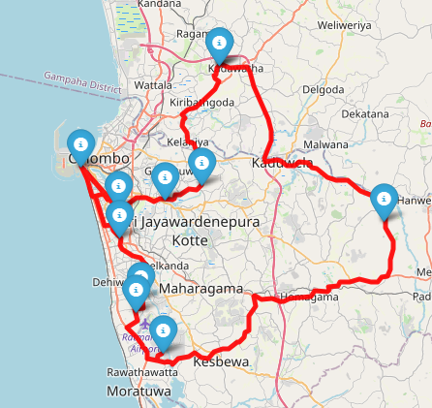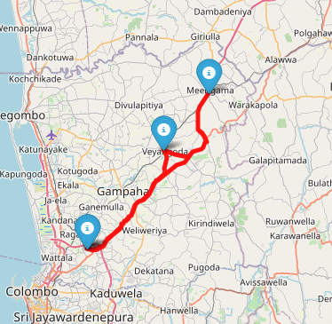Total distance for all vehicles: 174km